
STUDENT CASE STUDY EXECUTION REPORT
Department | FED
Subject | DSA-2
Academic Year | I-III Semester (2025-26)
Faculty Name | Ms. Alluri Swathi
Student Name | Shivam Tiwari
Roll Number | 2520080026
Branch | AI&DS
Course Outcome | CO1

Case Study Topic: EventSphere – Smart Event Planning & Management System Using BST & AVL Trees
Work Done Summary:
The application of Binary Search Trees (BST) and AVL Trees in managing event participant registration records efficiently. An Event Registration Management System was developed where participant records are stored, inserted, searched, and deleted using BST and AVL Trees. AVL balancing ensures faster searching and optimized registration management for large-scale events.
Implementation Details:
- Created BST and AVL Node classes with fields registrationId, participantName, eventName, left, right, and height.
- insert() method recursively inserts participant records.
- search() method retrieves participant details using Registration ID.
- delete() method removes cancelled registrations.
- inorderTraversal() displays participant records in sorted order.
- balanceFactor() calculates AVL balance factor.
- rotateLeft() method performs left rotation.
- rotateRight() method performs right rotation.
- comparePerformance() analyzes BST and AVL efficiency.
- Main method demonstrates insertion, searching, deletion, balancing, and traversal operations.
Result Screenshots/ Output:
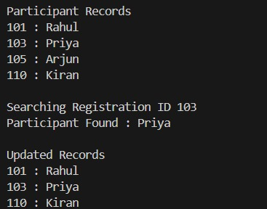
Time Complexity Analysis:
- BST Insert/Delete/Search : O(log n) Average
- AVL Insert/Delete/Search : O(log n)
- AVL Rotation : O(1)
- Inorder Traversal : O(n)

GitHub Link:
Student Signature | Faculty Signature

